**Introduction to the dataset:**

* Name - Name of the Book
* Author - The author of the Book
* User Rating - Amazon User Rating
* Reviews - Number of written reviews on amazon
* Price - The price of the book (As at 13/10/2020)
* Year - The Year(s) it ranked on the bestseller
* Genre - Whether fiction or non-fiction

**The questions I'll answer**:

* Which author's books receive the highest average rating (top authors)
* Which author has written the most bestsellers (top authors)
* Which book has the most reviews (top books)
* Which genres become bestsellers more often
* Are genres different by rating

**Data description and data cleaning:**

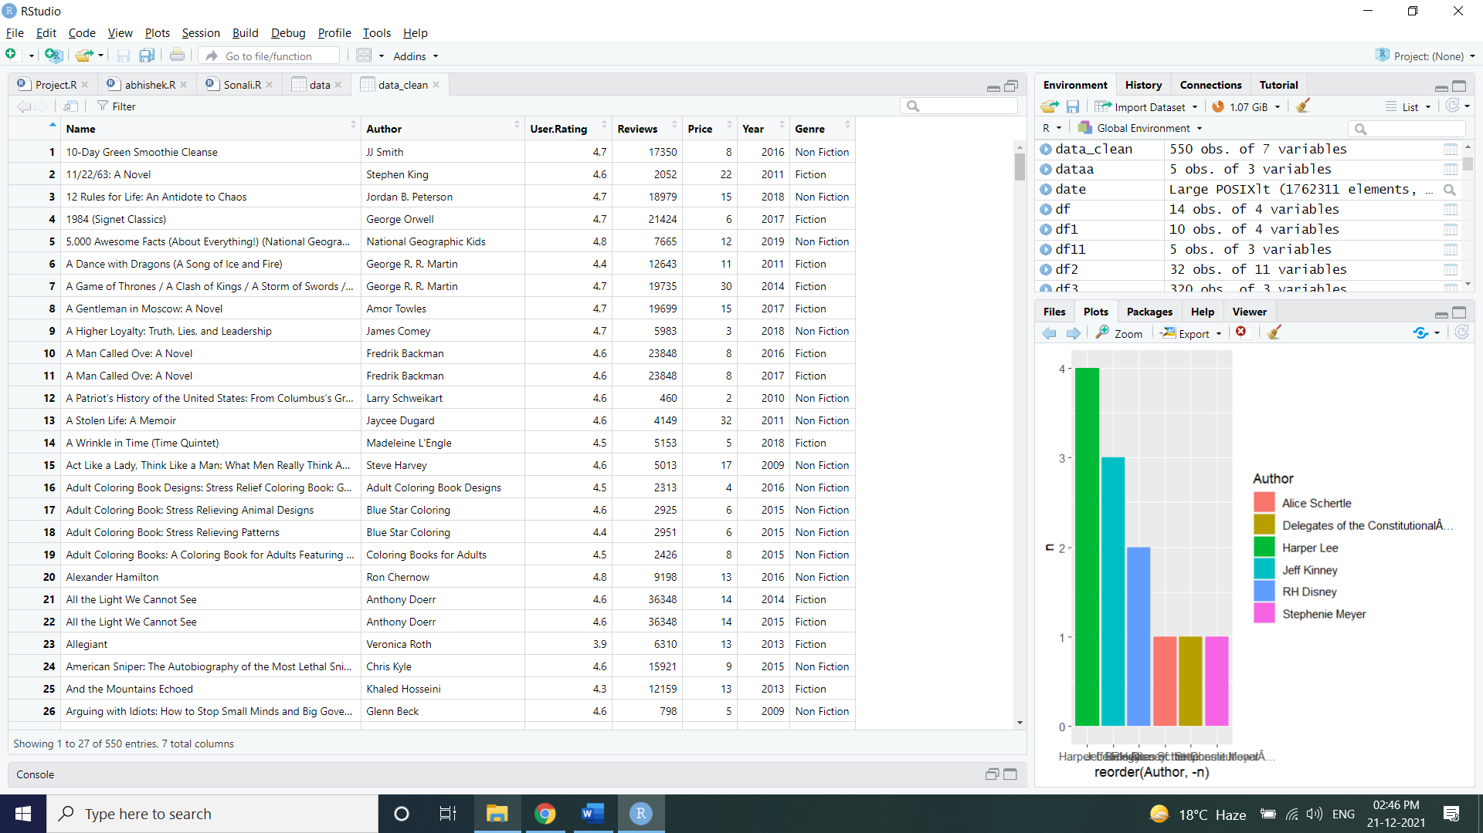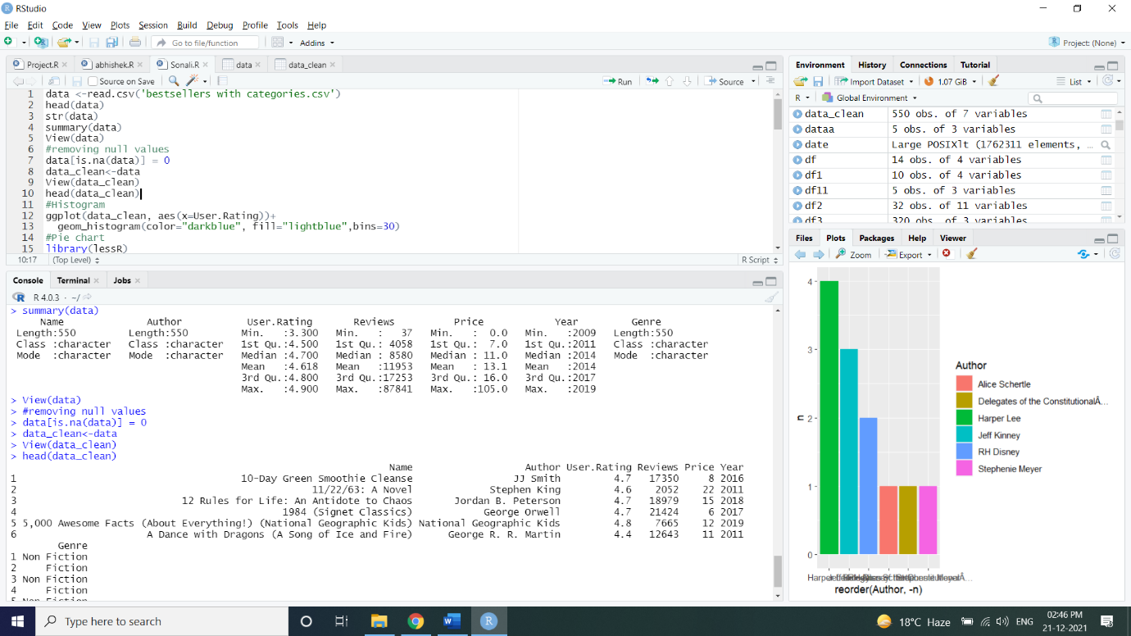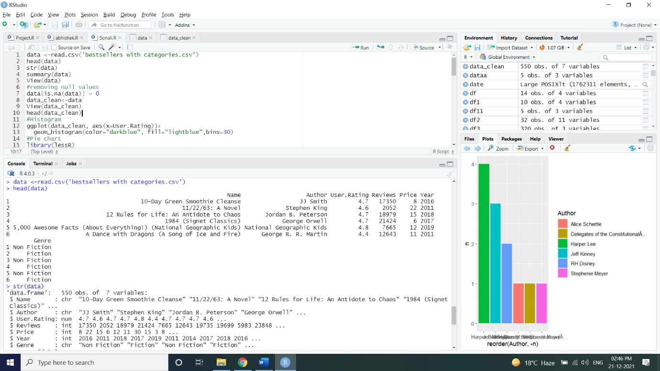

**Code:**

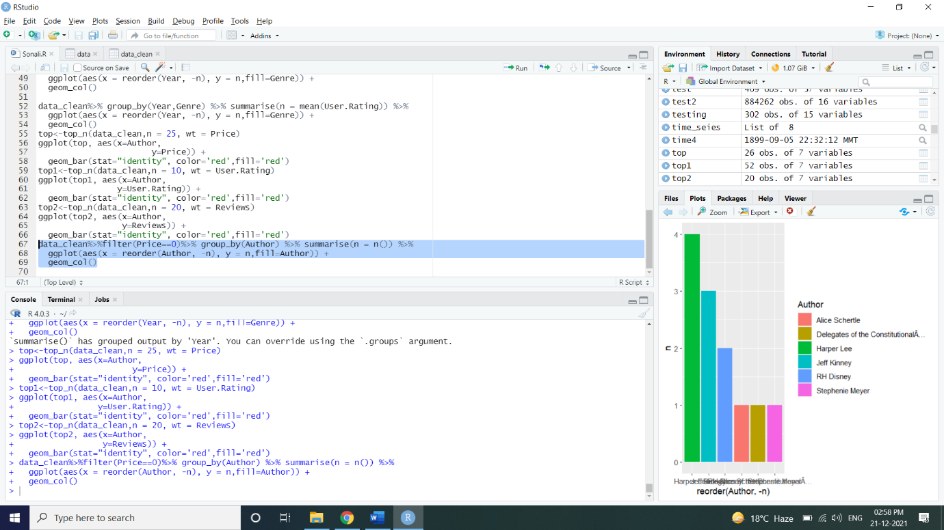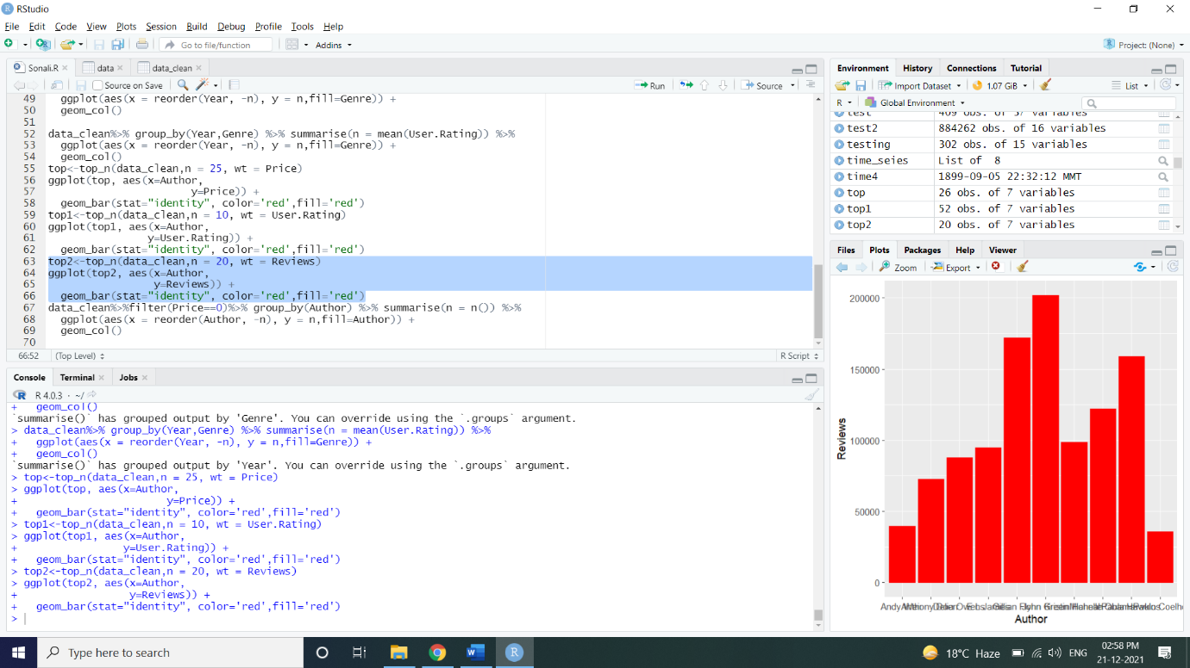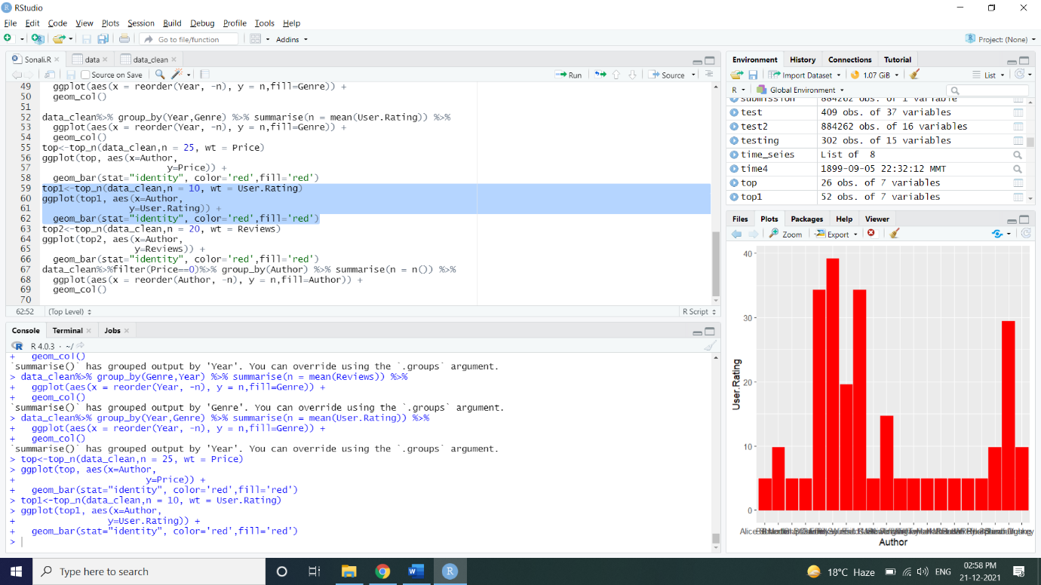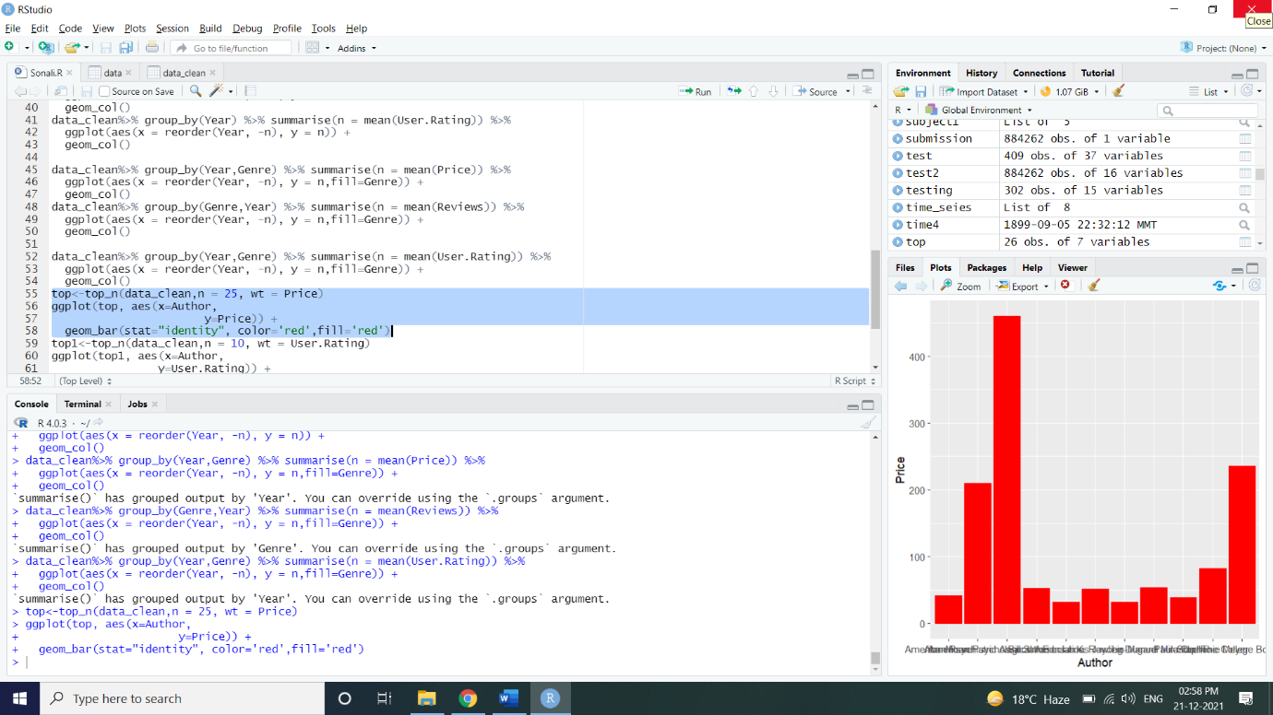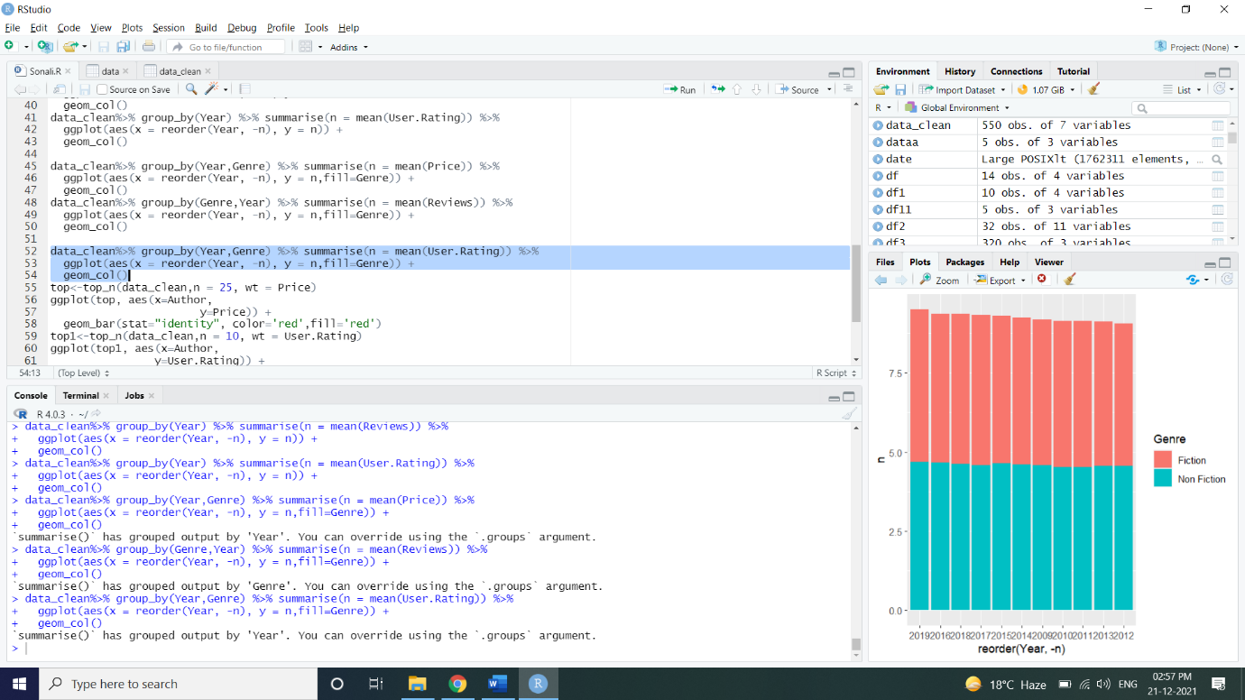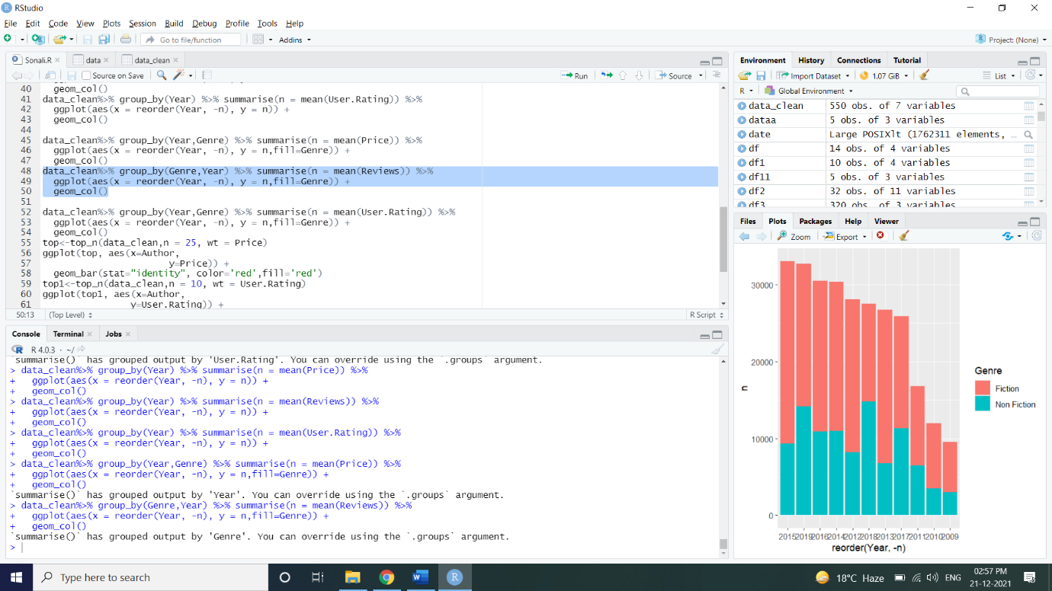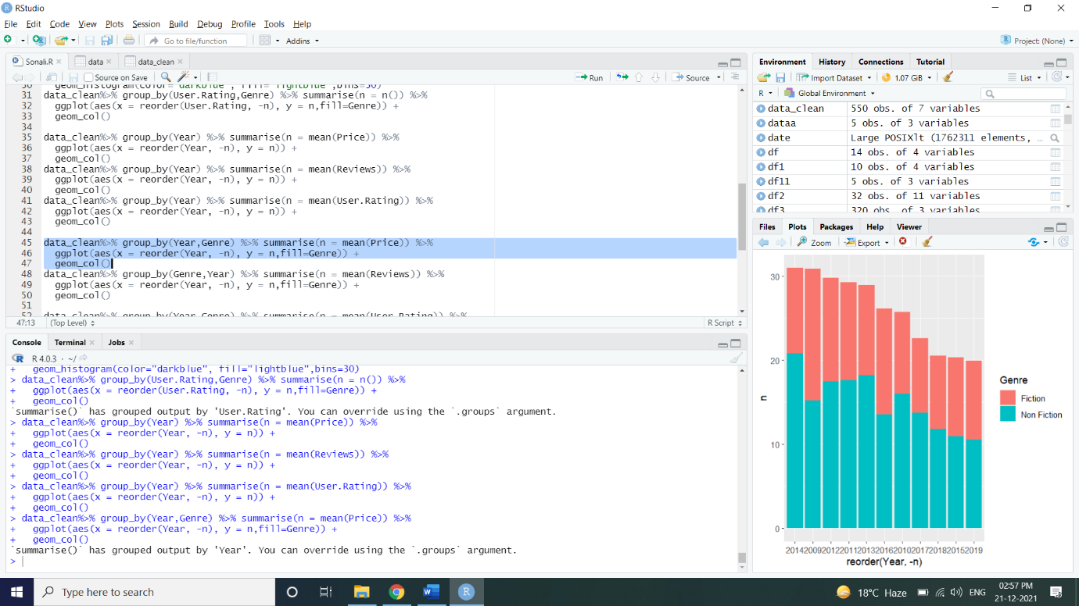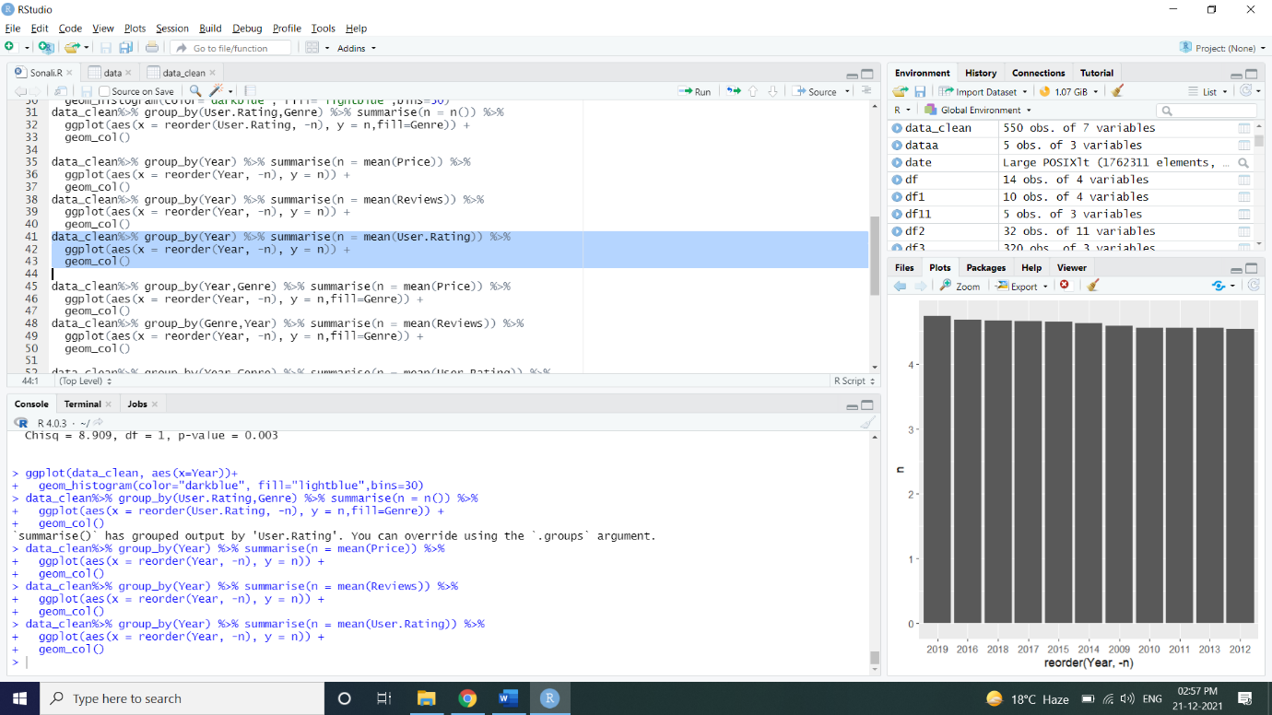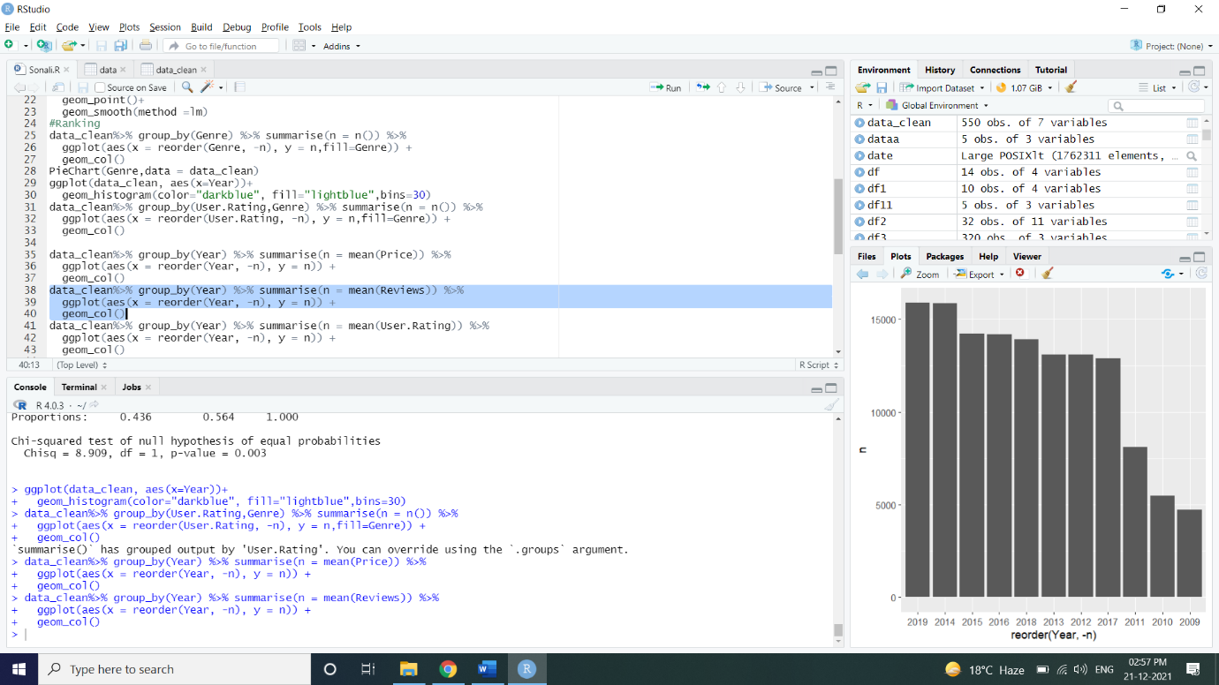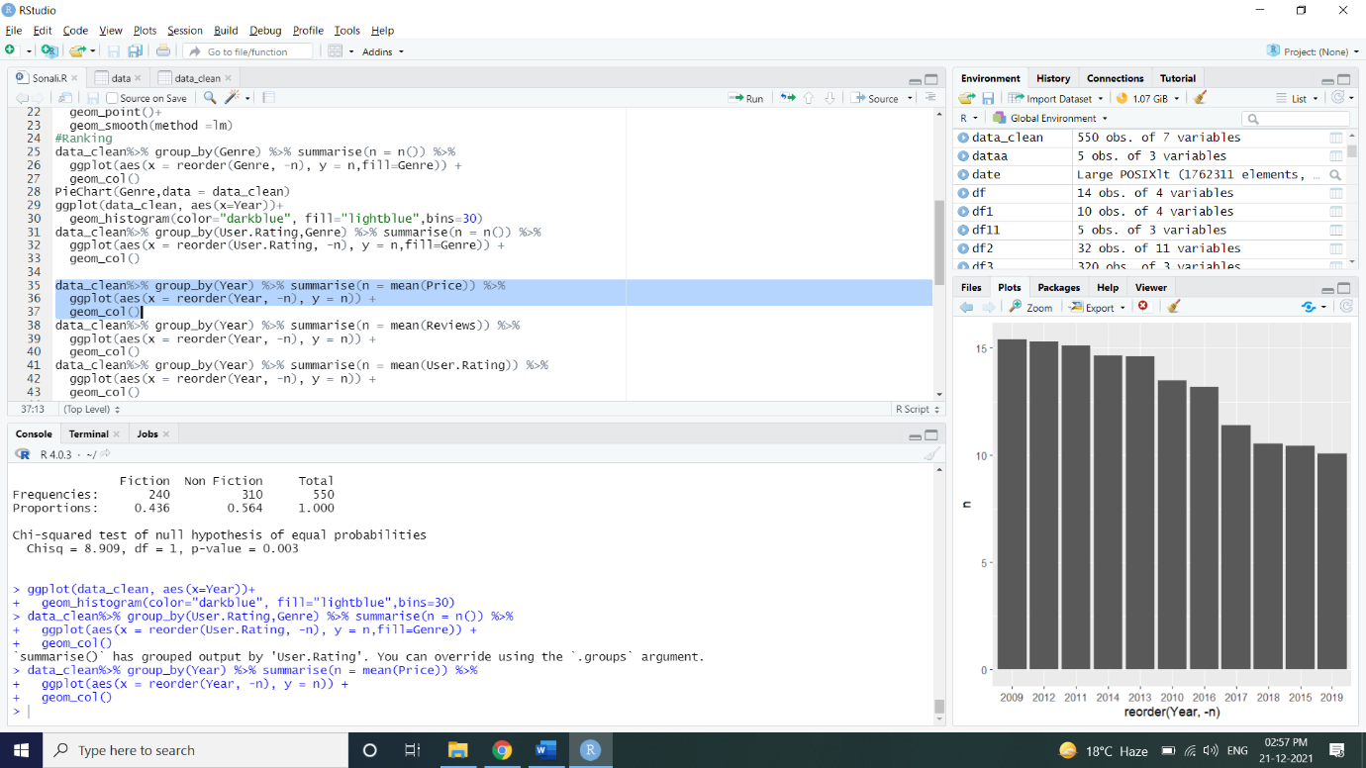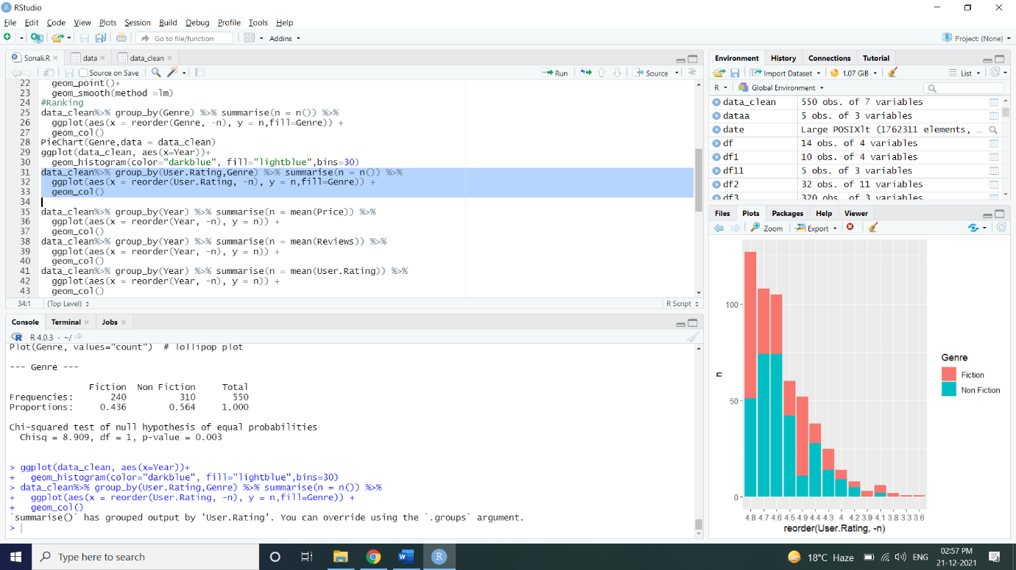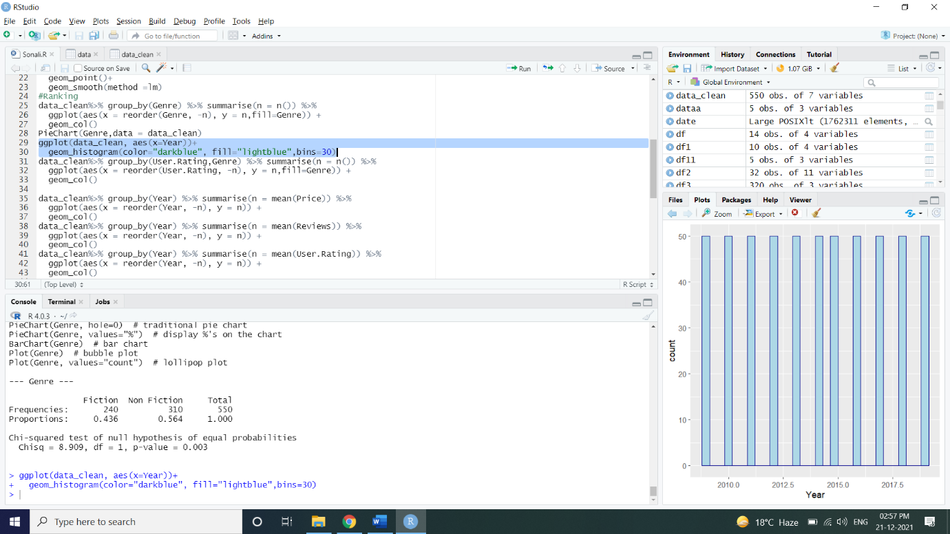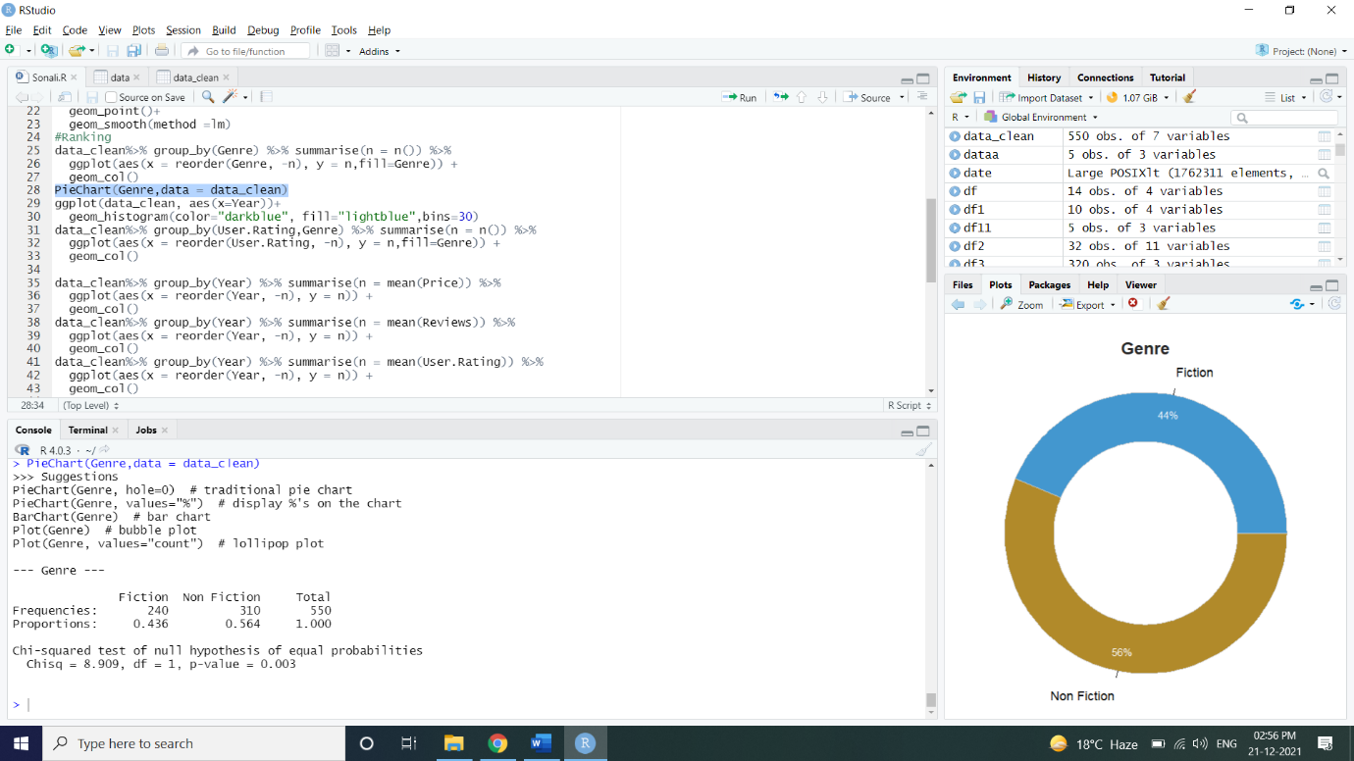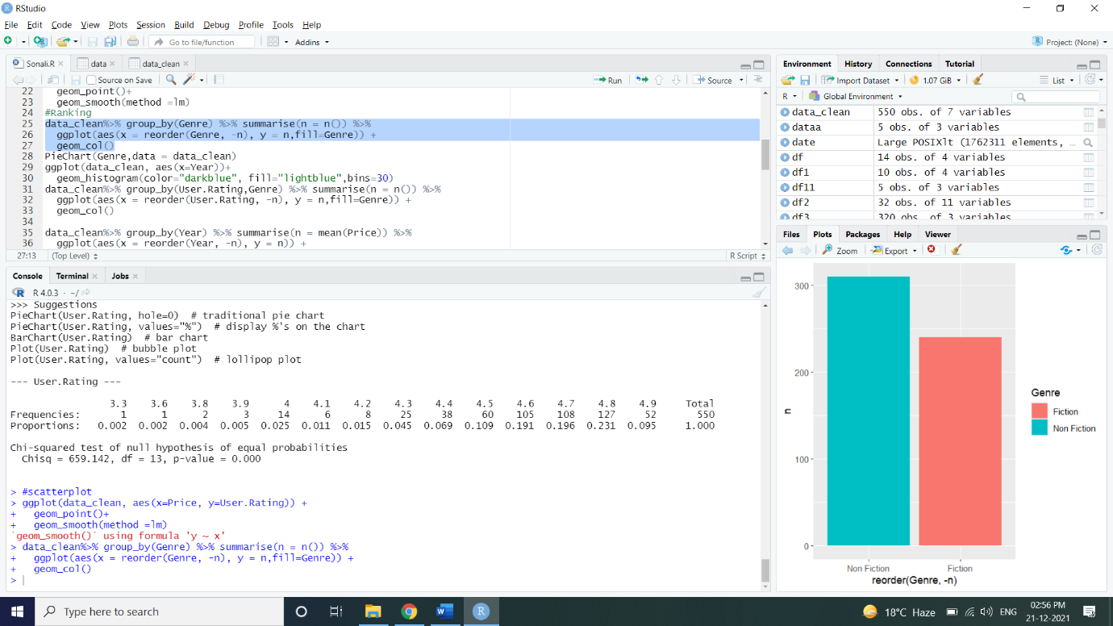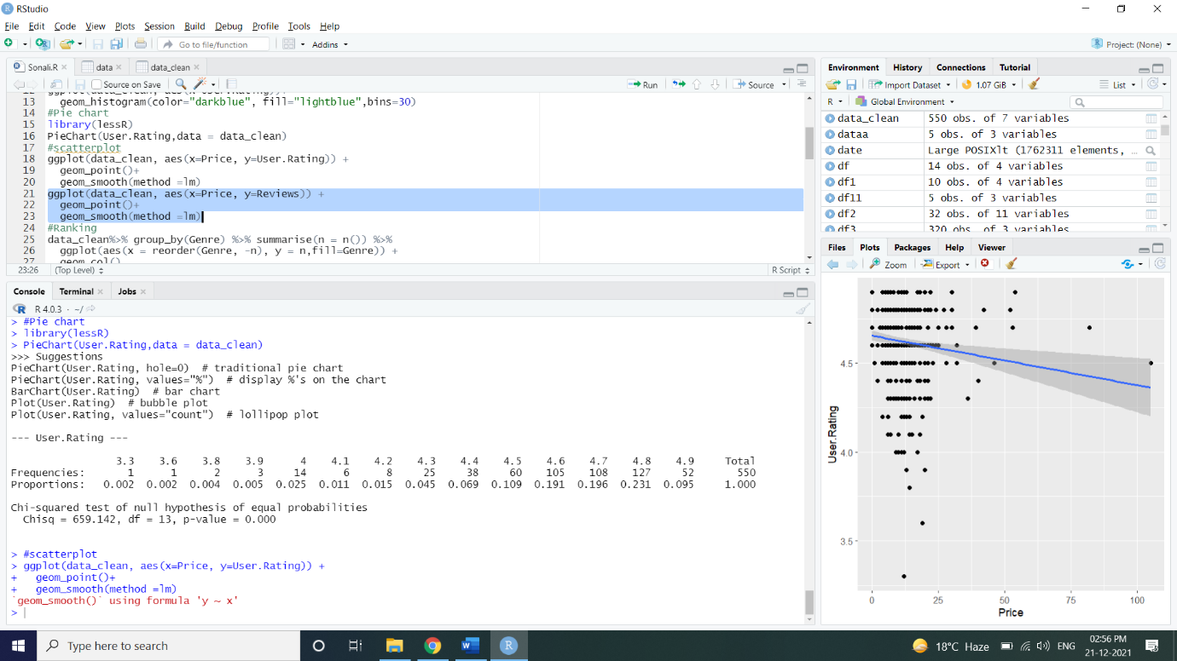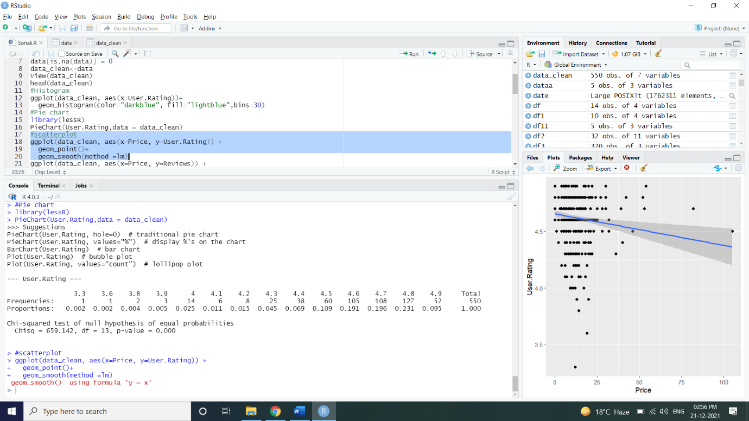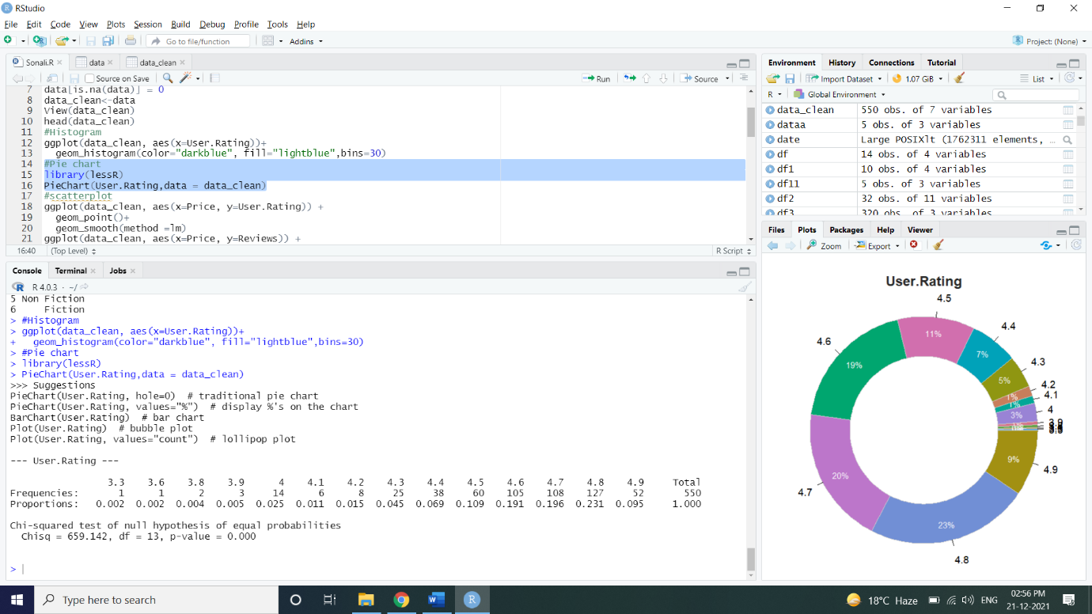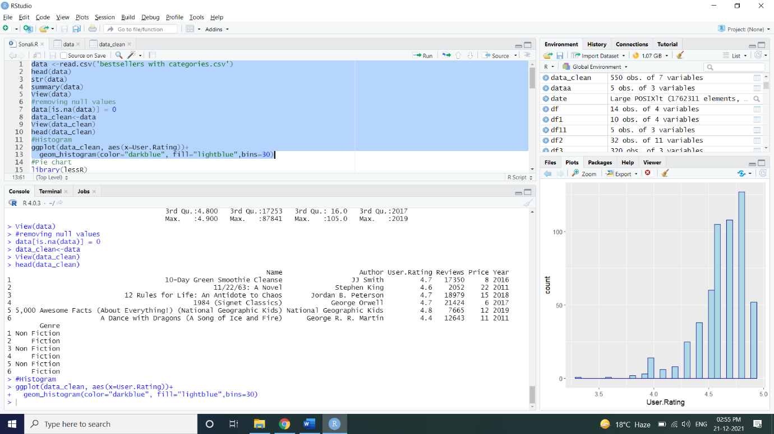

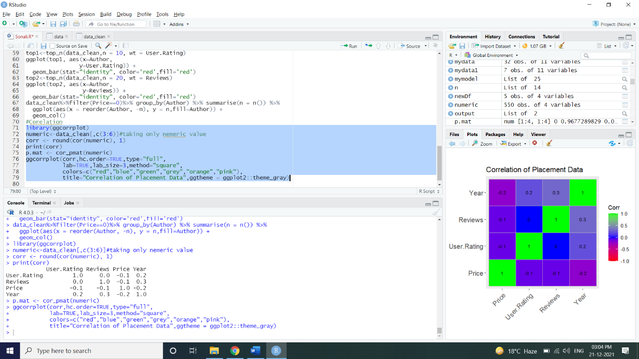



**CORRELATION:**

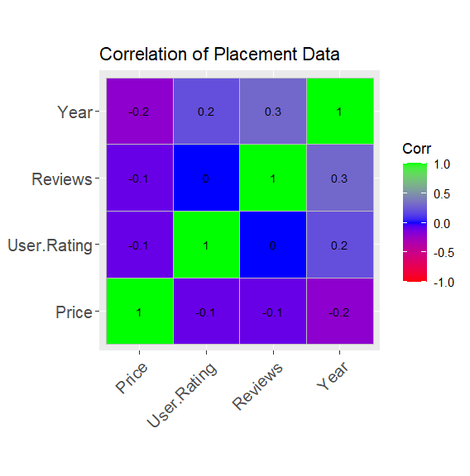

**BESTSELLERS' RATINGS COUNT:**

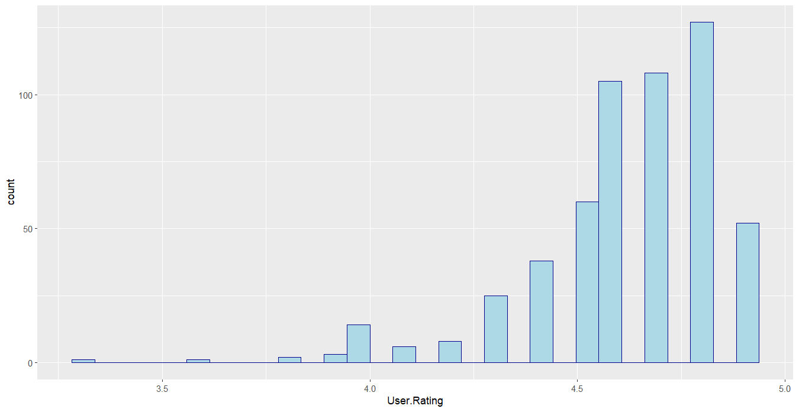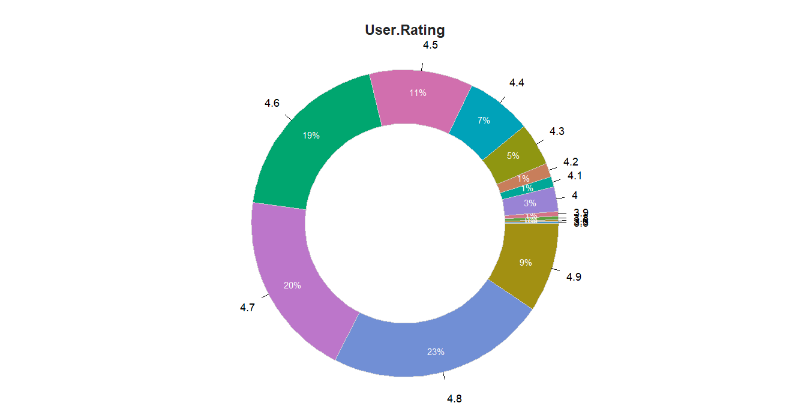

**MOST OF THE RATINGS ARE IN THE RANGE OF 4.6 TO 4.8**

**Relationship between Price and User Rating:**

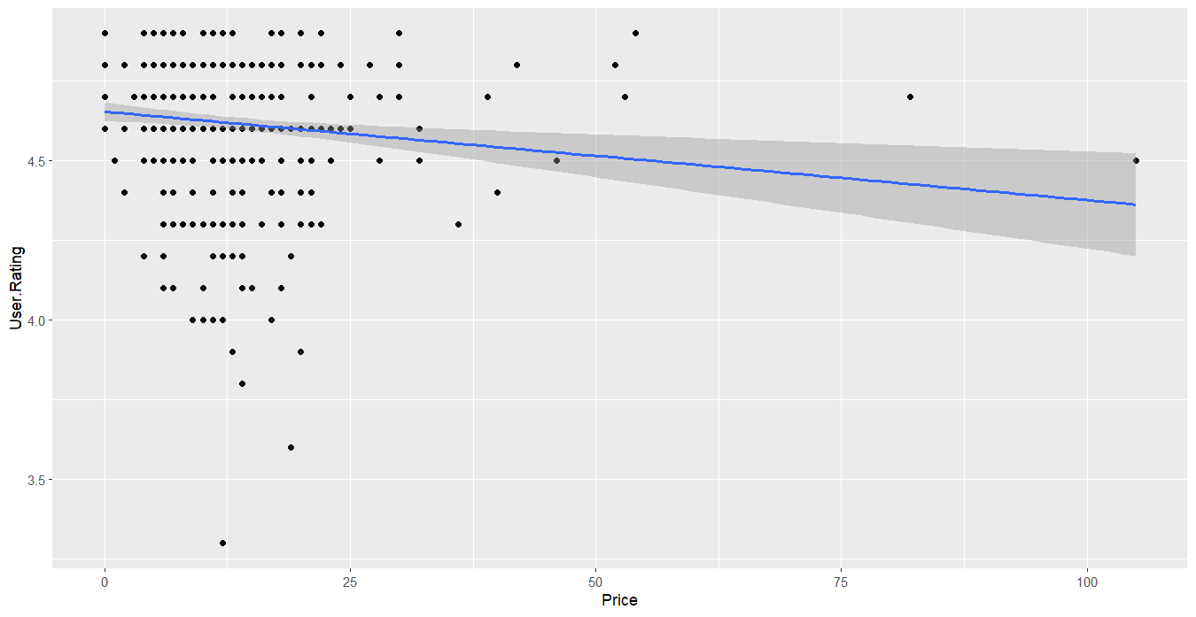

* **The User Ratings tend to show a slight negative correlation with Price of the Bestselling Book.**
* **Most of the books are in the 'Less than 50" price range, so not much conclusion can be drawn.**

**Relationship between Price and Reviews:**

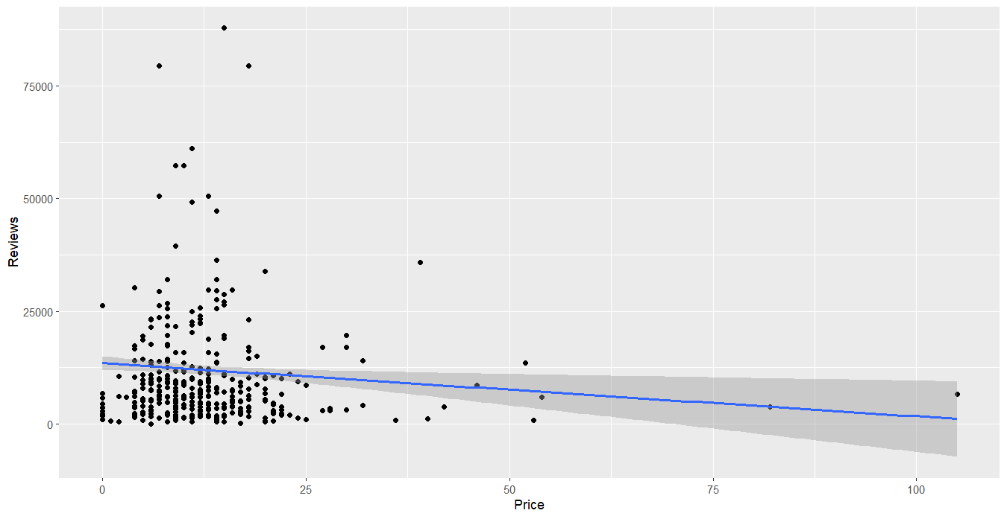

**Reviews and Price also tend to show an almost similar correlation as User Rating and Price. But again, as most of the Bestsellers are crowded in a lower Price range, we can't conclude much.**

**FICTION AND NON-FICTION BESTSELLERS:**

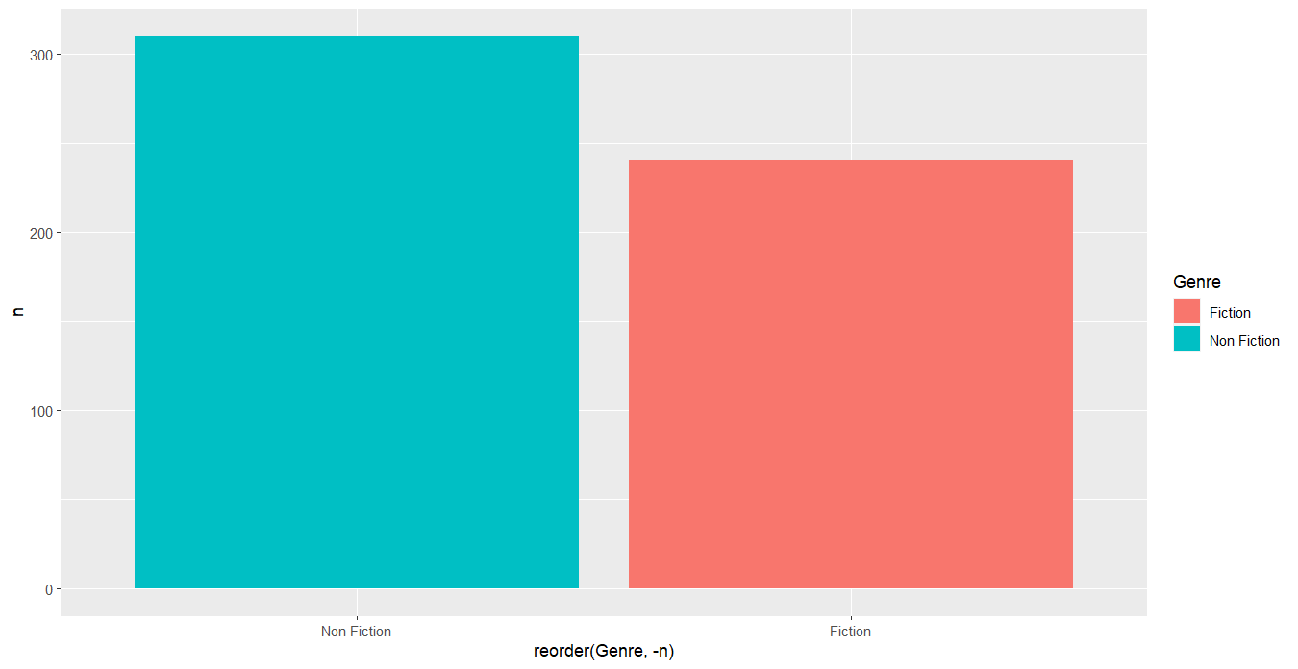

**NON-FICTION BESTSELLERS ARE MORE THAN FICTION**

**The number of bestselling books' count is Constantine. 50 for all the years. Their distribution with Genre can be seen the above plots.**

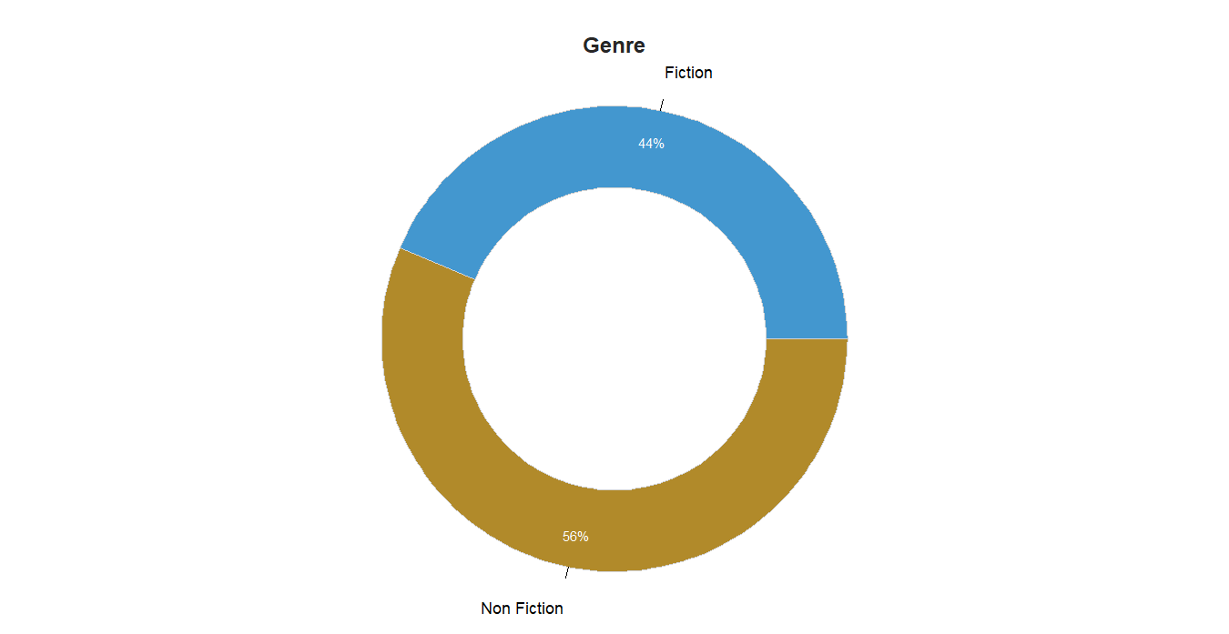

**For ratings less than 4.8, Non-Fiction books count overpowers Fiction books. But the reverse can be seen for the ratings-4.8 and 4.9. This is an important point as, earlier we have seen that non-fiction books have an overall higher count in the entire dataset.**

**REVIEWS, RATINGS AND PRICE OF BESTSELLERS BY YEAR:**

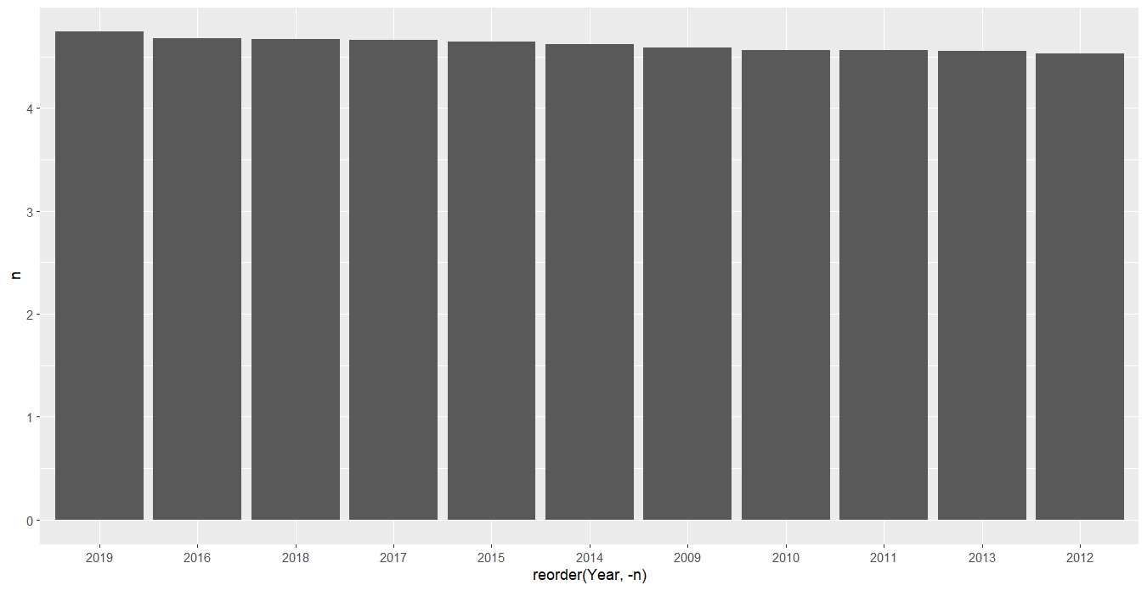

**Graph of Mean Price vs group by Year**

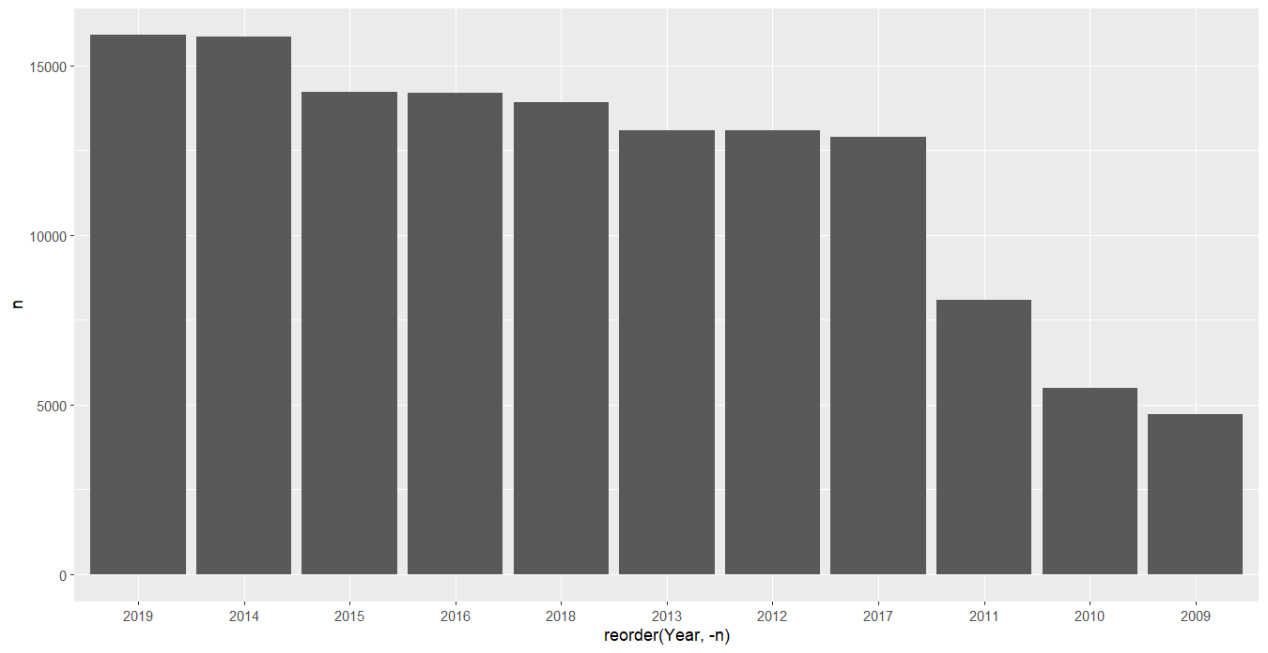

**Graph of Mean Reviews vs group by Year**

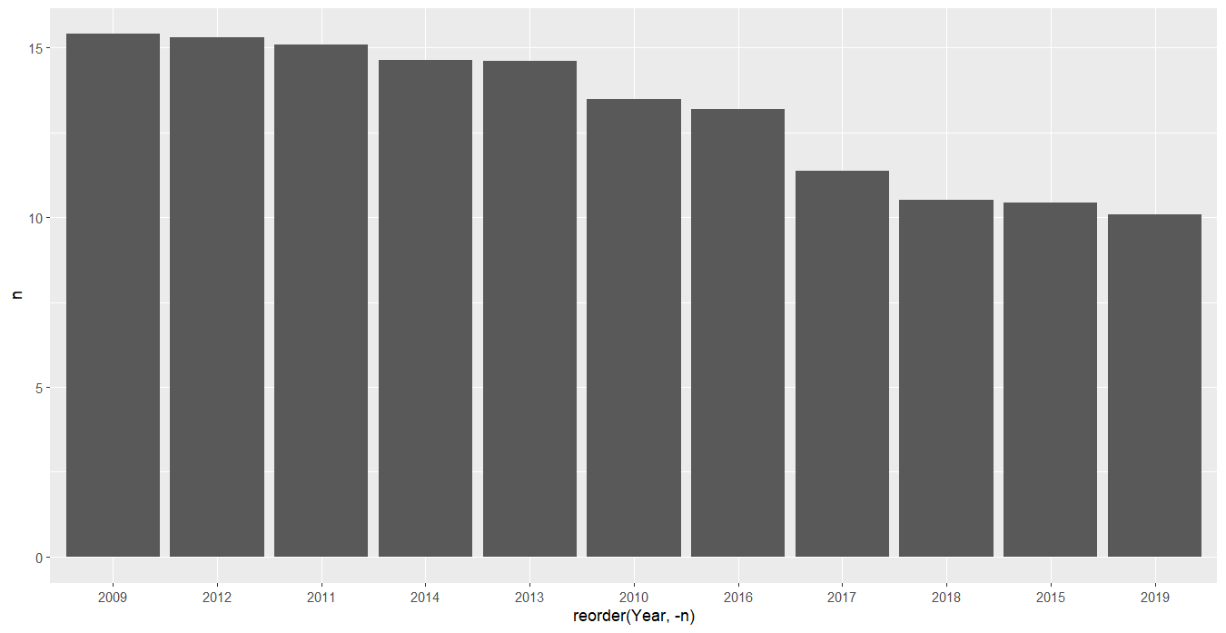

**Graph of Mean User.Rating vs group by Year**

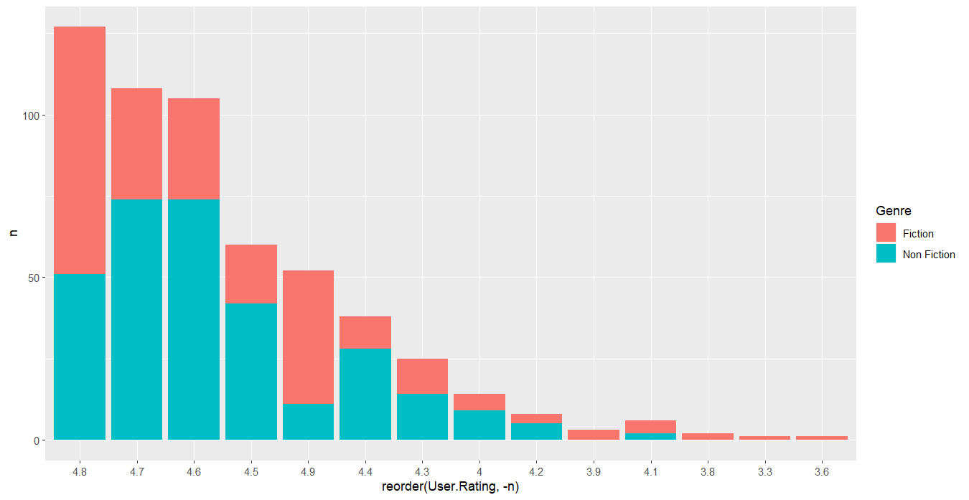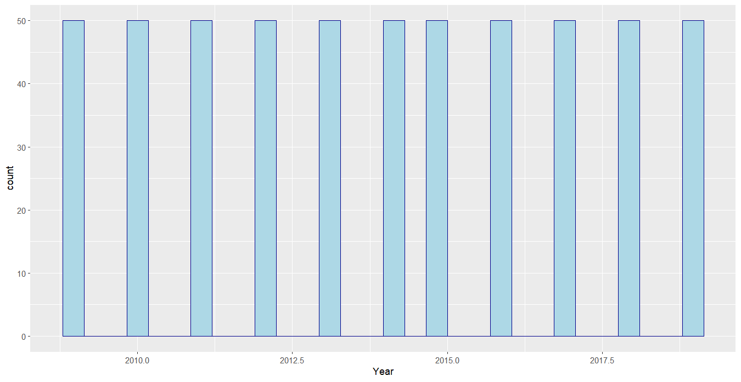

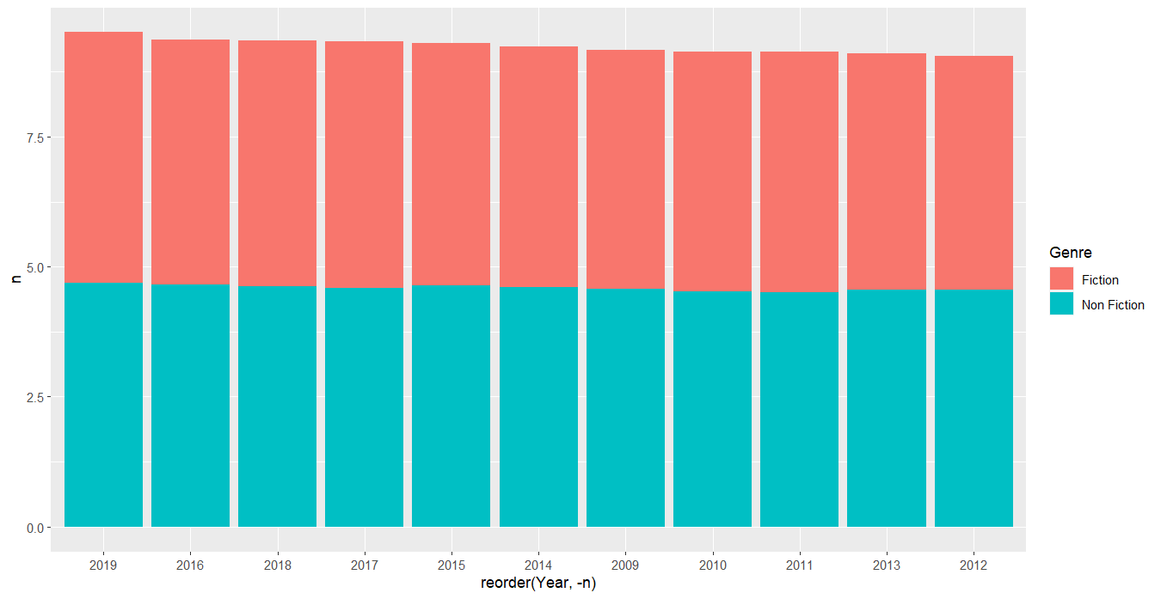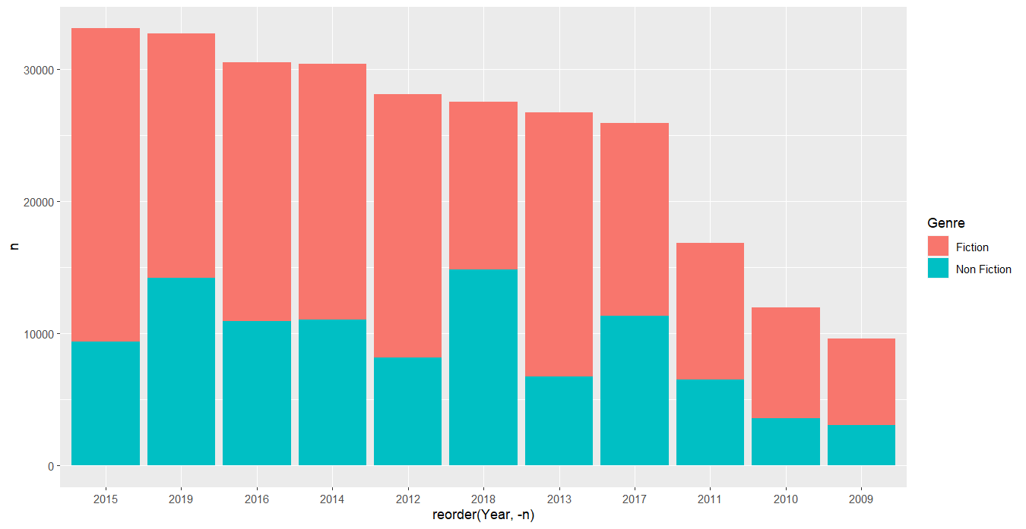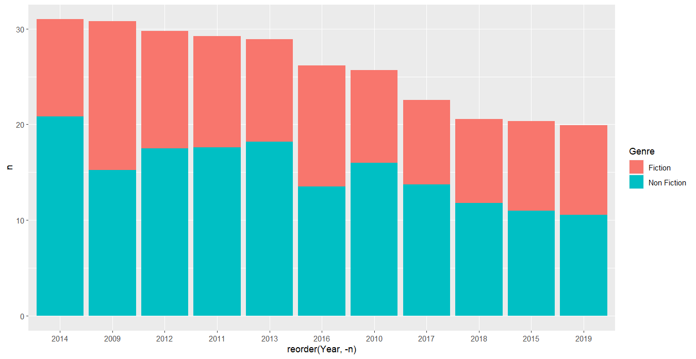

**BESTSELLING BOOKS' AUTHORS:**

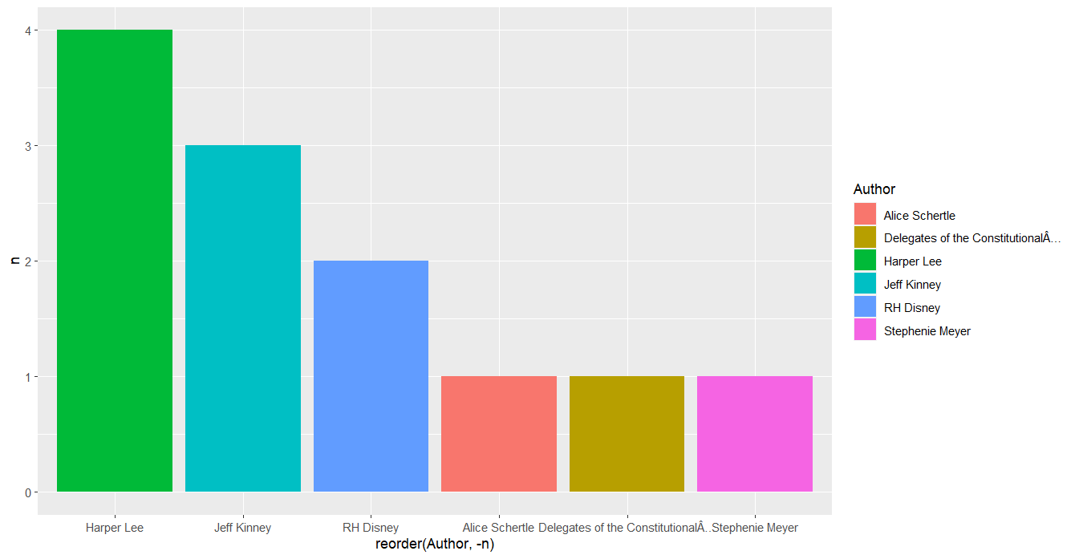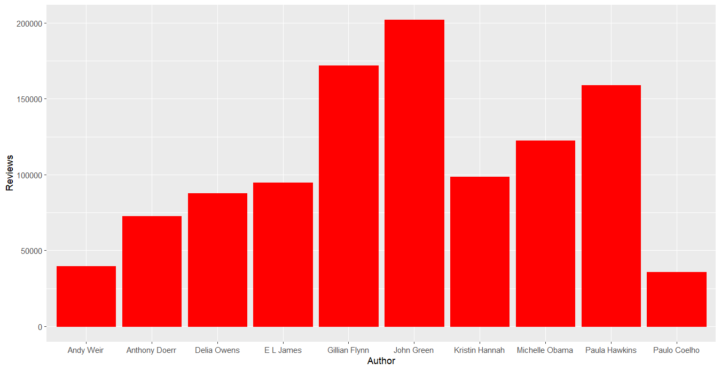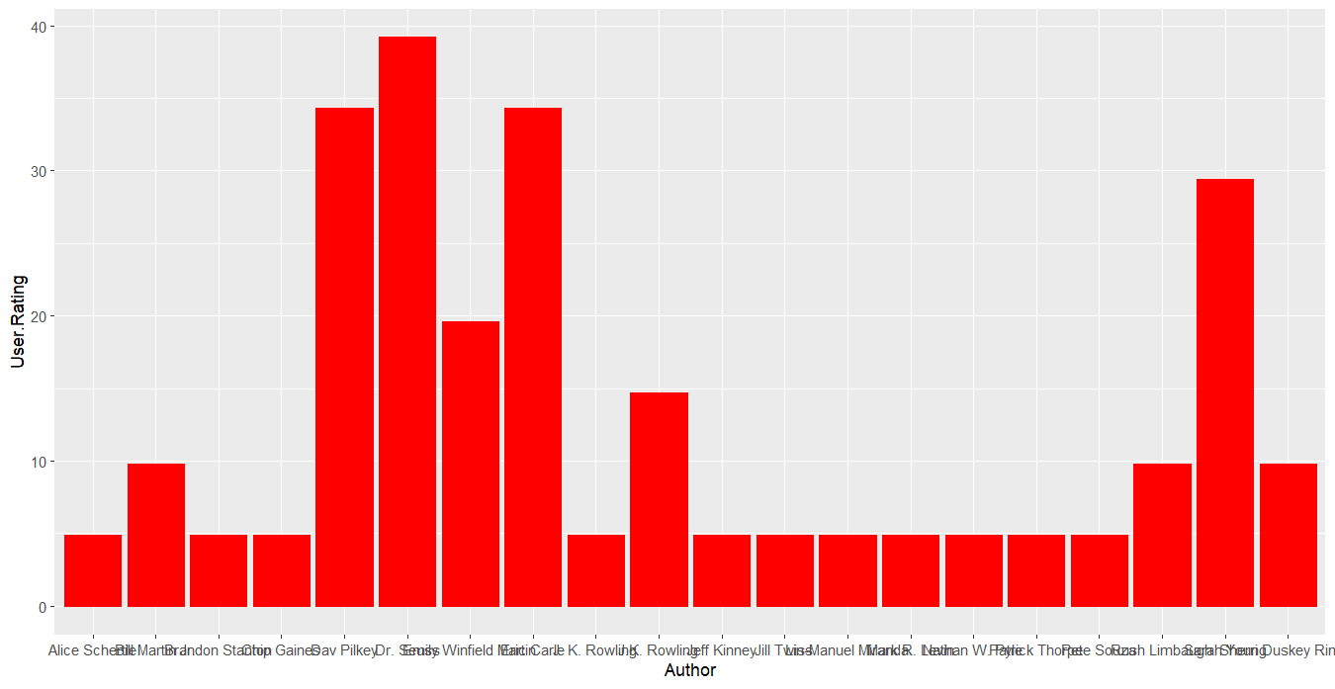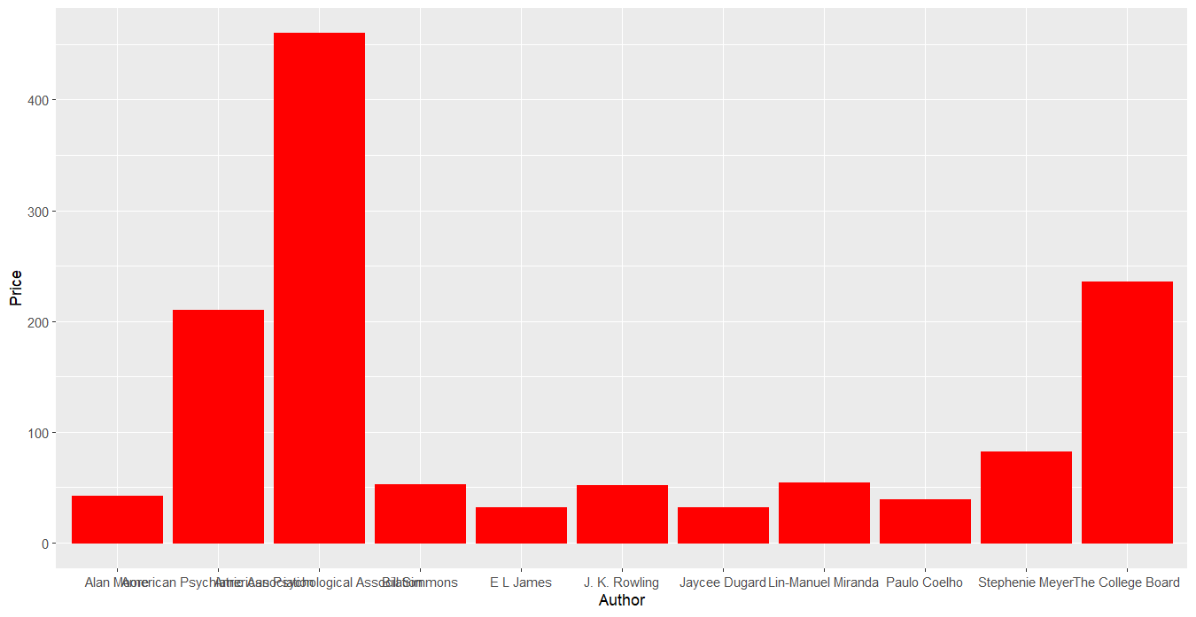

**Final Conclusions:**

* The following 13 authors have the highest rating: Nathan W. Pyle, Patrick Thorpe, Eric Carle, Emily Winfield Martin, Chip Gaines, Jill Twiss, Rush Limbaugh, Sherri Duskey Rinker, Alice Schertle, Pete Souza, Sarah Young, Lin-Manuel Miranda, Bill Martin Jr., Dav Pilkey. The average rating for their works was 4.9. When buying a new book, you should pay attention to these authors.
* Authors who have written more bestsellers: Jeff Kinney - 12 books, Rick Riordan - 10 books, J.K. Rowling - 8 books, Stephenie Meyer - 7 books, Dav Pilkey - 6 books, Bill O'Reilly - 6 books, John Grisham - 5 books, E L James - 5 books, Suzanne Collins - 5 books, Charlaine Harris - 4 books. These authors always have something to read.
* Books with the most reviews: Where the Crawdads Sing - 87841 Reviews, The Girl on The Train - 79446 Reviews, Becoming - 61133 Reviews, Gone Girl - 57271 Reviews, The Fault In Our Stars - 50482 Reviews. It's worth reading the book Where the Crawdads Sing, it's not for nothing that it is the most talked about.
* Non-fiction is more likely to become a bestseller.
* User Rating:
  + Data is not distributed normally. Asymmetry is observed.
  + Average and median book ratings are 4.6.
  + There are outliers in the data. There are a small number of books in the data below the 4.1 rating.
* Reviews:
  + Data is not distributed normally. Asymmetry is observed.
  + The data has a wide range.
  + There are outliers in the data. There are a small number of books receiving reviews well above the 75 percentiles.
* Price:
  + Data is not distributed normally. Asymmetry is observed.
  + There are books that cost much higher than the average, as well as books with a cost of 0, which is strange. Either the book is given for free or this error.
* Based on the constructed correlation matrix as well as the constructed visualizations, the data does not contain any positive or negative linear relationship between the rating, reviews and the price of books
* As a result of the testing, statistically significant differences were obtained between the compared groups. Based on the results obtained, it can be argued that users evaluate books differently depending on the genre, and based on the median values, readers give preference to works of fiction